Induction Portal login help document for Internet Explorer 11

Please follow below steps if you are using Internet Explorer 11 and facing issue like Login Button not visible and IE explorer reports as if you are using Mozilla Firefox browser.
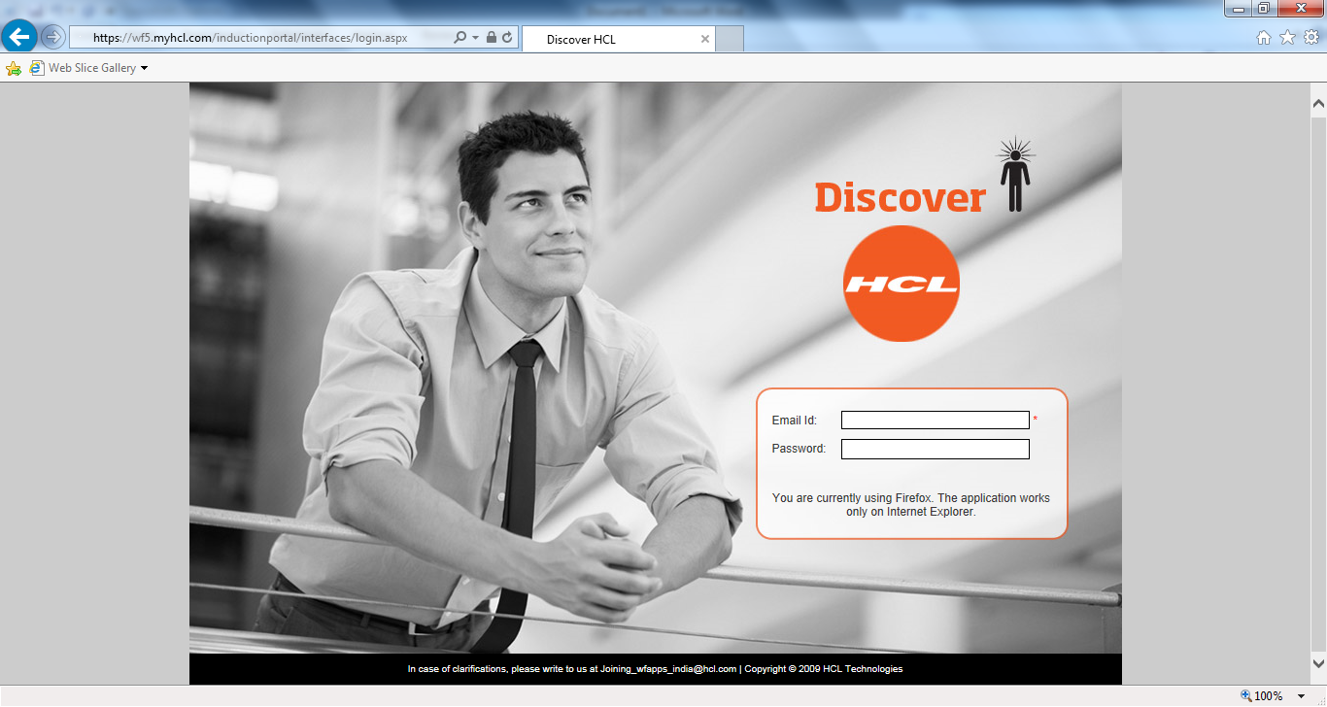
- Press F12 while Internet Explorer window is active.
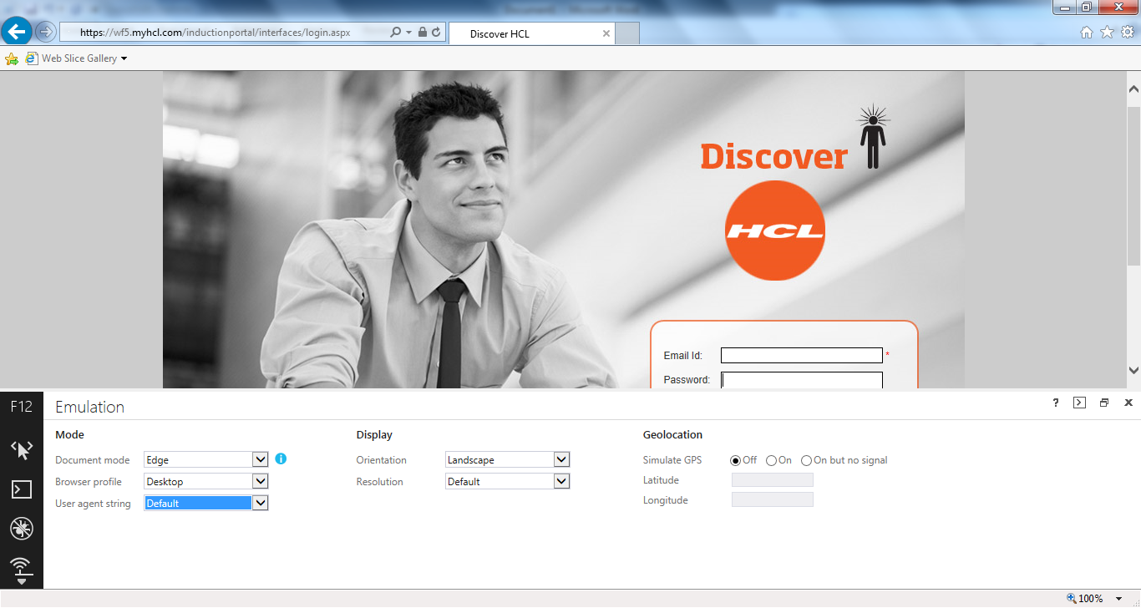
- Select Emulation Icon (Highlighted Icon in below screenshot) from sidebar of Internet Explorer 11.
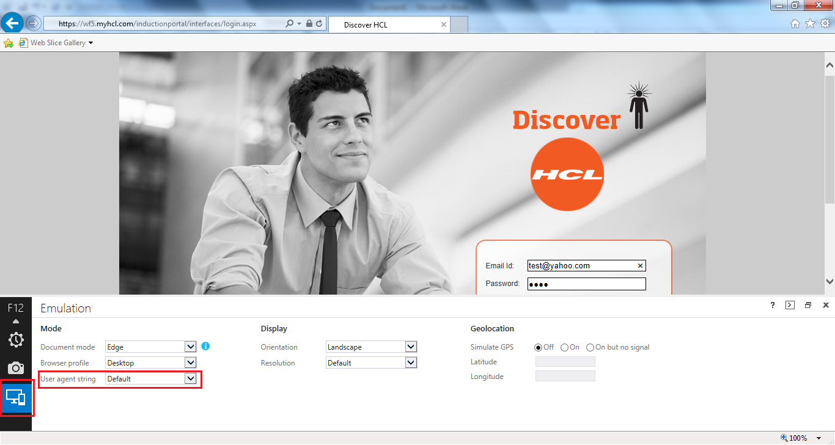
- Change the User agent string to IE10 version or lower as shown in below screen.
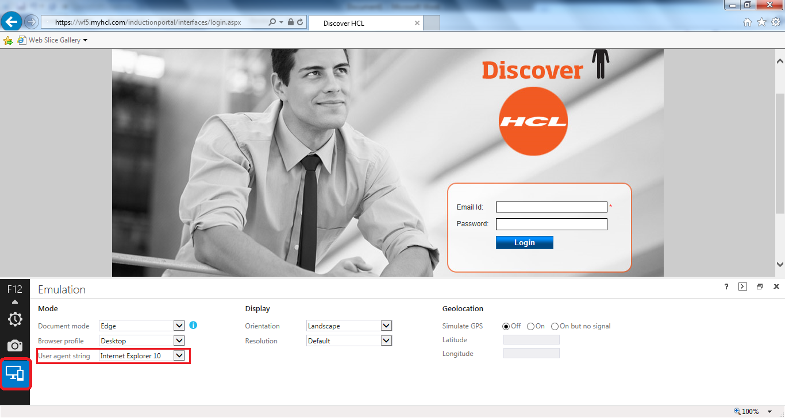
- Now Login Button should be visible on Induction Portal Login page.

Note: - In case you are not able to login page even following above steps then contact at mailto:Joining_wfapps_india@hcl.com

